Compound assignment or short hand operators: Here we are using = operator with the combination of other operators as follows.
+=, -=, *=, %=, /=, ~=,<<=,>>=,..
Eg:
int a=10, b=20;
float c=5;
a+=2; 🡺 i.e. a=a+2 🡺 10+2 🡺12
b*=5; 🡺 i.e. b=b*5 🡺20*5 🡺 100
c/=2; 🡺 i.e. c=c/2 🡺 5/2 🡺 c=2.500000
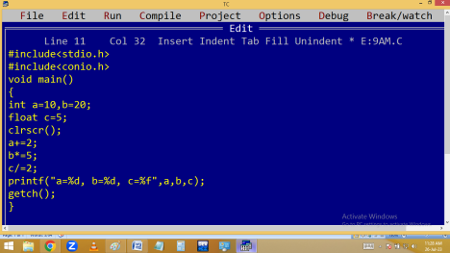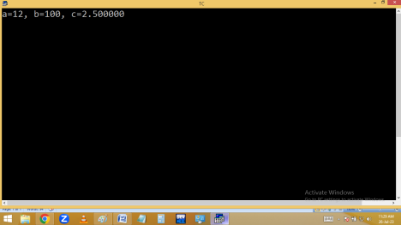
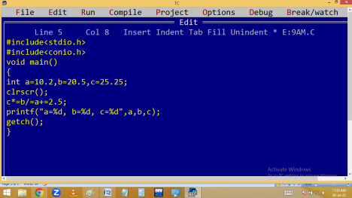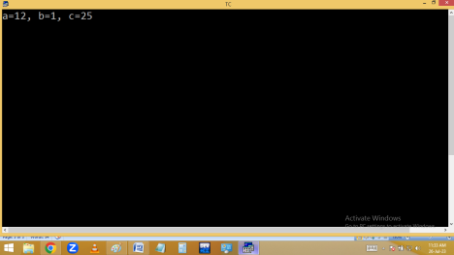
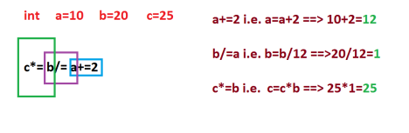
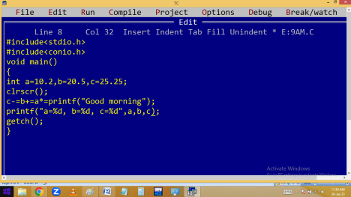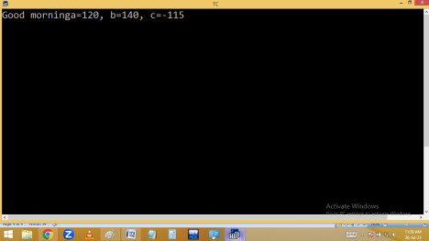
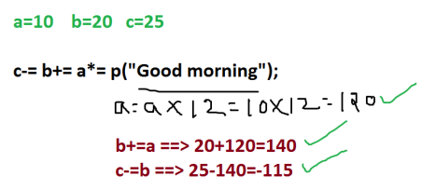
( ) and , separators:
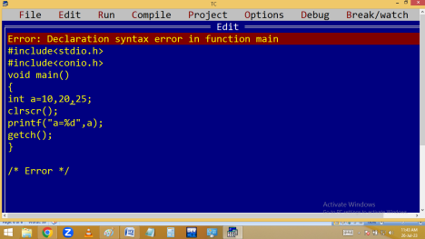
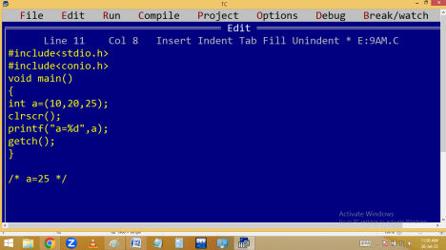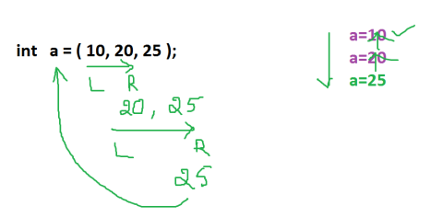
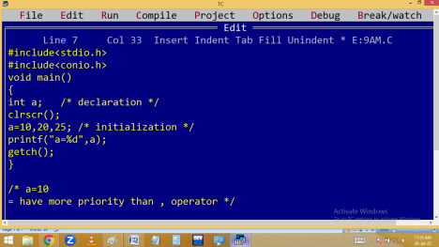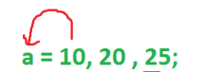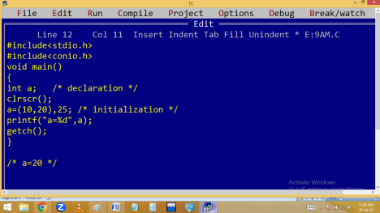
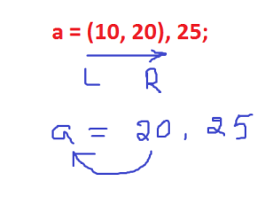
Address operators:
1.& - Address of variable
2. * - pointer – stores address of another variable
sizeof() operator:
It return the no of bytes taken by a variable / data type / value.

